Ex. No.:6 | AI-POWERED MEDICAL SYMPTOM ASSISTANT USING GPT-4 | URK23CS1121
22.10.2026 | AI-POWERED MEDICAL SYMPTOM ASSISTANT USING GPT-4 | URK23CS1121

Aim:

To develop an AI-powered medical symptom assistant using GPT-4 that analyzes user-reported symptoms, identifies possible associated conditions, generates relevant follow-up questions and provides general guidance regarding professional medical attention.

Problem Statement:

Design and develop an AI-powered medical symptom assistant using GPT-4. The application should collect basic user information and symptoms, analyze the reported symptoms, identify possible conditions, generate follow-up questions and present the results in a structured format. The system should include appropriate safety instructions and clearly state that the generated output is not a medical diagnosis.

Software Requirements:
Software | Version
Python | 3.10.0
Ollama | 0.40.8
VS Code | 1.95.3
Pandas | 2.3.3
Sentence Transformers | 6.1.0

Input Parameters
Parameters | Description
Age | 22 years
Sex | Female
Symptoms | Fever, cough, sore throat, chills, fatigue, body aches, shortness of breath, chest pain (Extracted: Cough, Fever, Sore throat, Chills, Fatigue)
Duration | 2 days
Severity | Mild
Medical History | No known relevant condition
Medication | None
Allergies | None
Additional Information | Vital signs (temperature, respiration status) pending evaluation; No known adverse drug reactions.

System Architecture
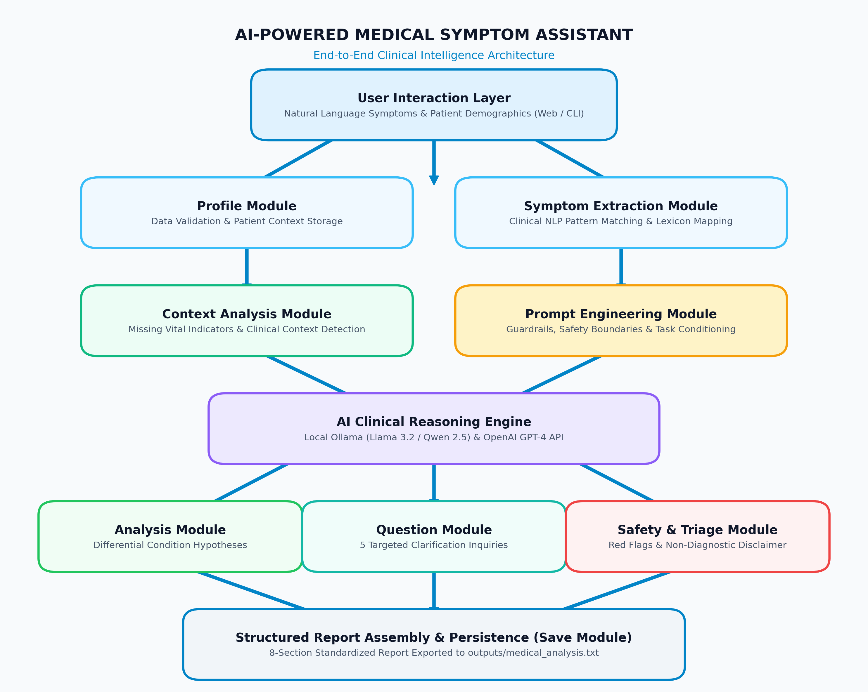

Module Design

Module | Responsibility
Input Module | Collects patient demographic information, medical history, and natural language symptom descriptions interactively and from benchmark datasets.
Profile Module | Encapsulates, validates, and serializes patient profile parameters into structured models for prompt construction and reporting.
Symptom Module | Extracts discrete clinical symptoms from conversational natural language narratives using clinical NLP pattern matching and phrase normalization.
Context Module | Analyzes patient profile and symptom context to detect missing critical clinical parameters (e.g., measured temperature, breathing difficulty, progression).
Prompt Module | Constructs guardrailed system and user prompts for GPT-4/Ollama enforcing non-diagnostic boundaries, uncertainty communication, and structured output formatting.
Analysis Module | Interfaces with the LLM engine (local Ollama Llama 3.2 or OpenAI GPT-4) to generate preliminary condition hypotheses with clinical reasoning.
Question Module | Dynamically formulates 5 targeted clinical follow-up questions tailored to reported symptoms and detected missing context to resolve clinical ambiguity.
Safety Module | Performs red-flag screening (cardiovascular, respiratory, neurological), determines risk escalation levels (Low, Moderate, Urgent), and enforces the mandatory medical disclaimer.
Save Module | Compiles the comprehensive 8-part structured clinical analysis report and persists it to outputs/medical_analysis.txt.
Main Module | Orchestrates the entire multi-module workflow, providing both a 9-option interactive terminal CLI and a visual web application launcher.

Implementation
GitHub Repository: https://github.com/DeepakKrishnanSU/AI-Powered-Medical-Symptom-Assistant-using-GPT-4
LinkedIn Post: https://lnkd.in/p/gmazMz7E

Output Screenshots:

Home Screen:
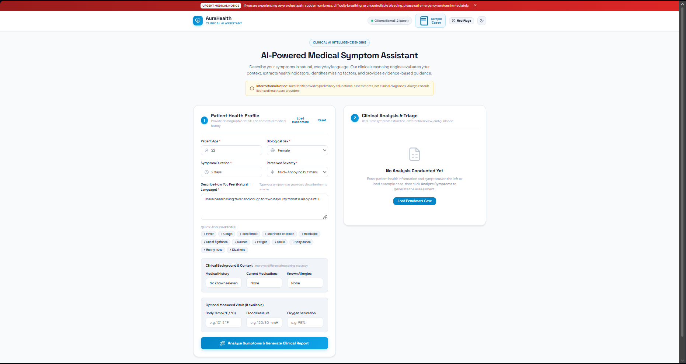
- Patient Information Input:
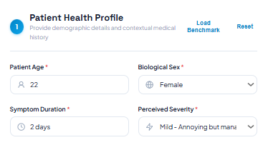
- Symptom Input:
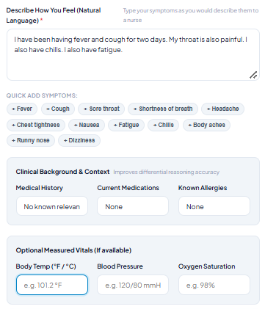
- Extracted Symptoms:
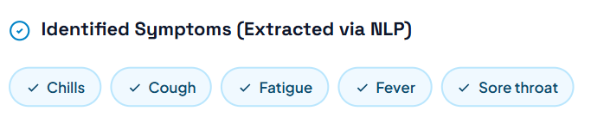
- Context Analysis:
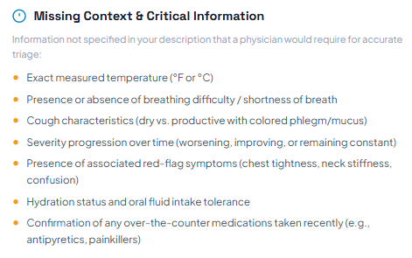
- Prompt Generation:
- GPT-4 Response:
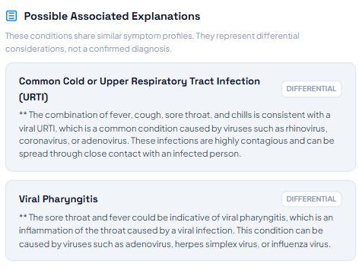
- Possible Conditions:
- Follow-up Questions:
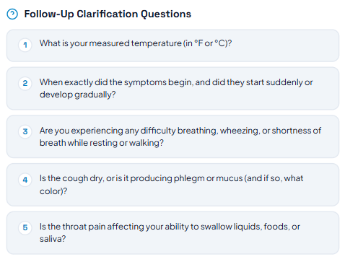
- Medical Attention Guidance:
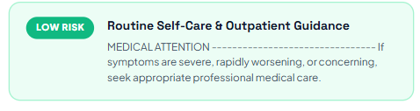
- Complete Structured Analysis:
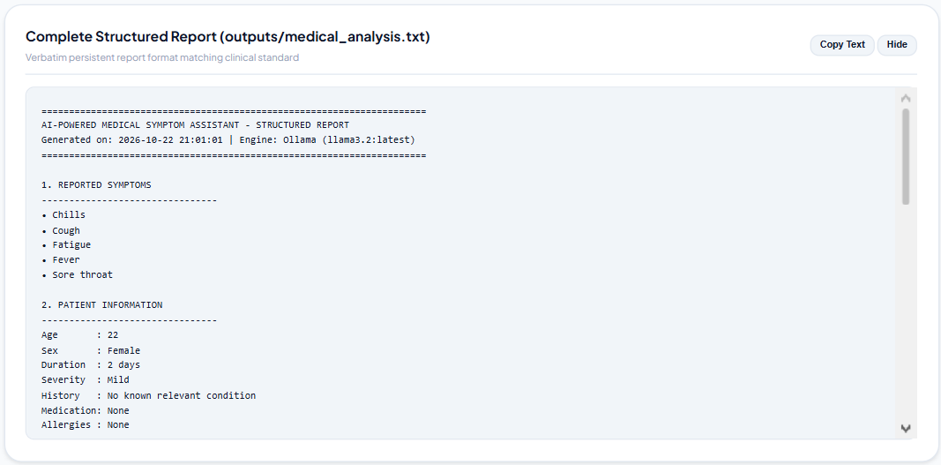
- Disclaimer:
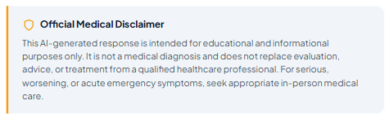
- Saved Report:
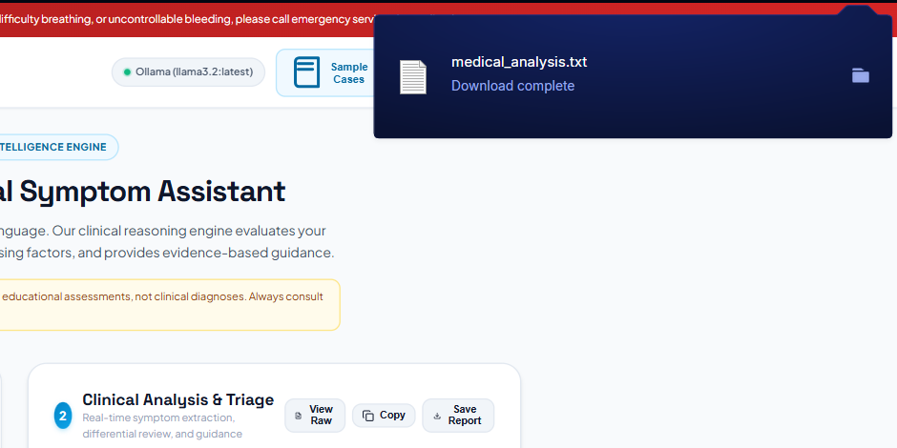

Result:
Thus, an AI-powered medical symptom assistant using GPT-4 was successfully developed. The system accepts user-reported symptoms and relevant contextual information, performs preliminary symptom analysis, generates possible conditions and follow-up questions, provides appropriate medical-attention guidance and produces a structured informational response with a safety disclaimer.

